**考点位置示意图**

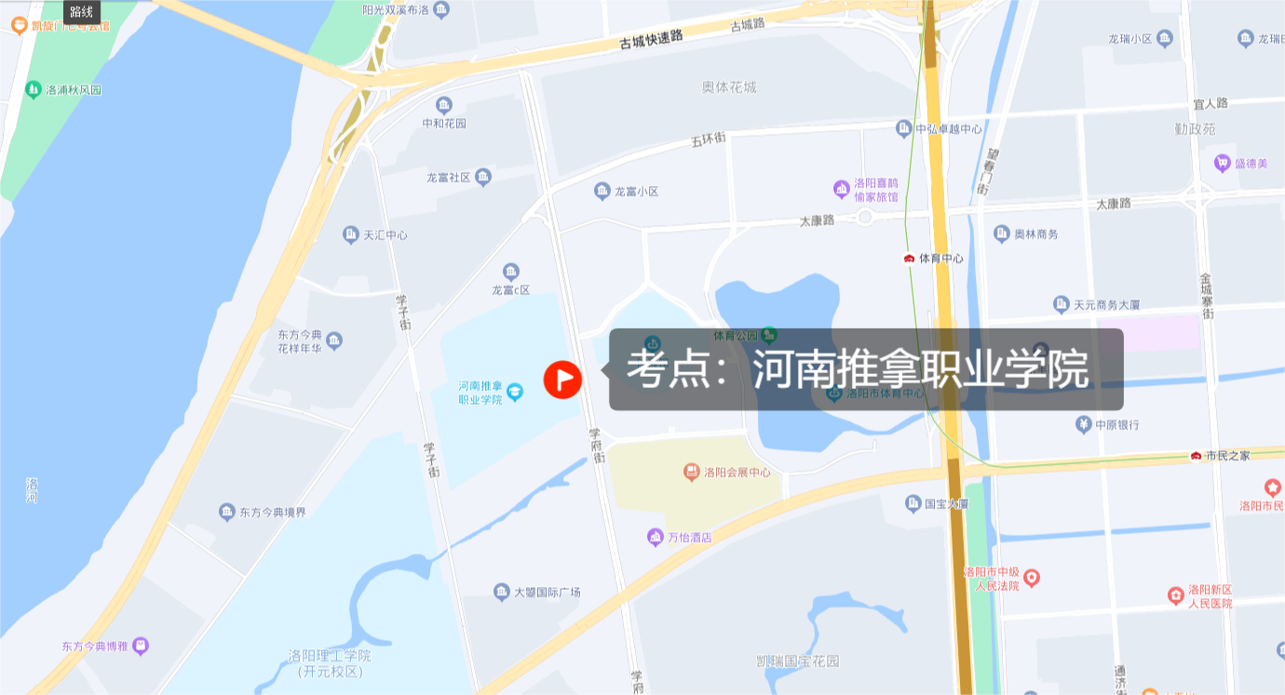

考点地址：洛龙区学府街10号。学府街上南向北205、57、35路，北向南205、35路，在河南推拿职业学院有站；地铁2号线体育中心站A1出口步行约1400米；私家车可停放在学府街两边辅路（收费）停车位或考点对面体育中心（收费）、会展中心（免费）停车场。

**考场外部示意图（3号教学楼5层501室）**

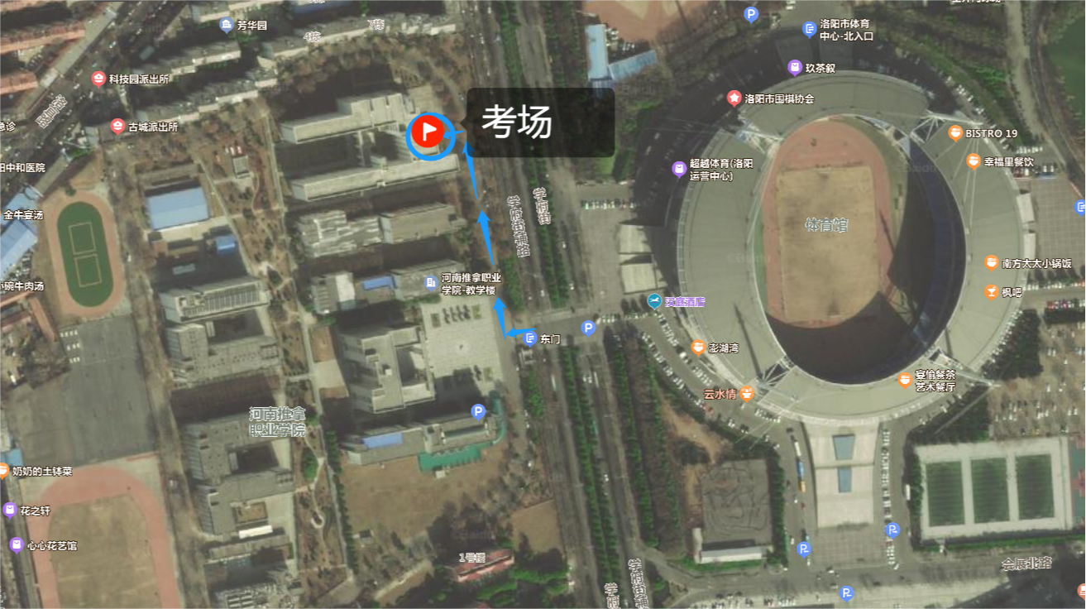

从河南推拿职业学院东门进入，进门右转，向北约140米左转到达3号教学楼，进门右转，走步梯上5层按考场内部示意图进入501教室。

**考场内部示意图**

|  |  |  |  |  |  |  |  |  |  |  |  |  |  |  |  |  |  |  |  |  |  |  |  |
| --- | --- | --- | --- | --- | --- | --- | --- | --- | --- | --- | --- | --- | --- | --- | --- | --- | --- | --- | --- | --- | --- | --- | --- |
| **教室** | | | | | | | | | | | | | | **楼梯** | | | | | | | | | |
| **走廊** | **小广场** | | | | | | | | | | | | | | | | | | | | | | |
| **504教室** | | | | | | | | | | | | | | | | | | | | | | |
| **北** | | | | | | | | | | | | | | | | | | | | | | |
| **讲台** | **西** | | **68** | **67** | **66** | **65** | | **64** | **63** | **62** | **61** | **60** | | **59** | **58** | **57** | **56** | **55** | **54** | **53** | **52** |  |
| **35** | **36** | **37** | **38** | | **39** | **40** | **41** | **42** | **43** | | **44** | **45** | **46** | **47** | **48** | **49** | **50** | **51** |
| **东** | | | | | | | | | | | | | | | | | | | |
| **34** | **33** | **32** | **31** | | **30** | **29** | **28** | **27** | **26** | | **25** | **24** | **23** | **22** | **21** | **20** | **19** | **18** |  |
| **1** | **2** | **3** | **4** | | **5** | **6** | **7** | **8** | **9** | | **10** | **11** | **12** | **13** | **14** | **15** | **16** | **17** |
| **501教室入口 南** | | | | | | | | | | | | | | | | | | | | | | |
|  | | **走廊** | | | | |  | | | | | | | | | | | | | | | |